**Question 3.**

**Feedbacks:**

1. No error while we enters only … in the Name, Surname Middle Name. It must contains alphabets only.

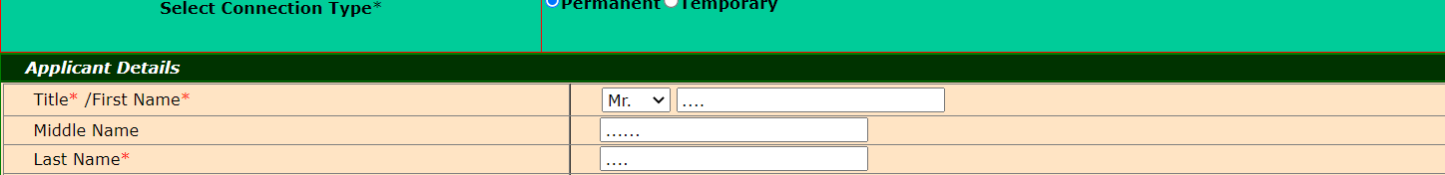

1. Building number should be numeric, but here user is able to enter alphabets



1. User should enter below fields manually. Ex. PIN number (User can have different PIN other than available in list)



1. User is able to enter values in wrong datatype without any error or warnings in Rental Tab.

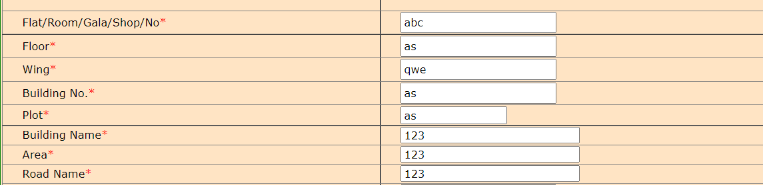

1. Yes button is not clickable, user should able to click both the buttons.

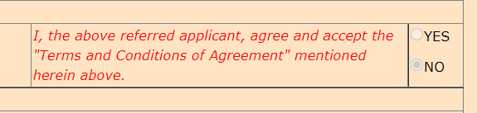

1. No Success failure message after uploading the document.

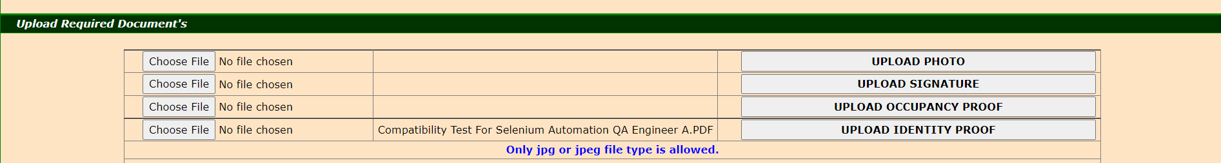

1. Upload photo- user is not able to see any option to browse the picture.

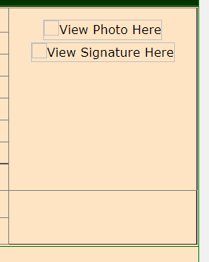

1. Yes button is disabled, user is not able to click Yes button



1. After clicking on Reset All button, some fields are not able to clean the data.

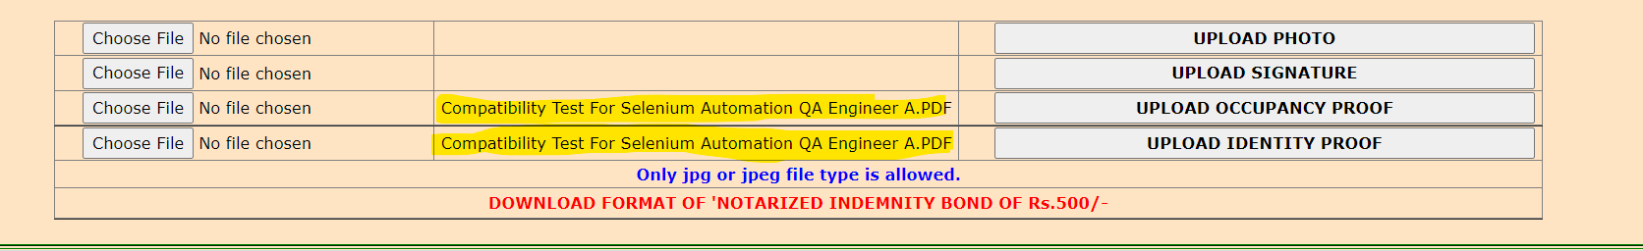

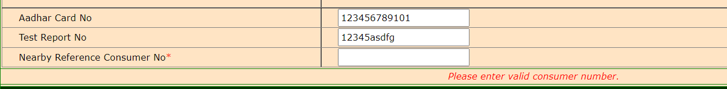



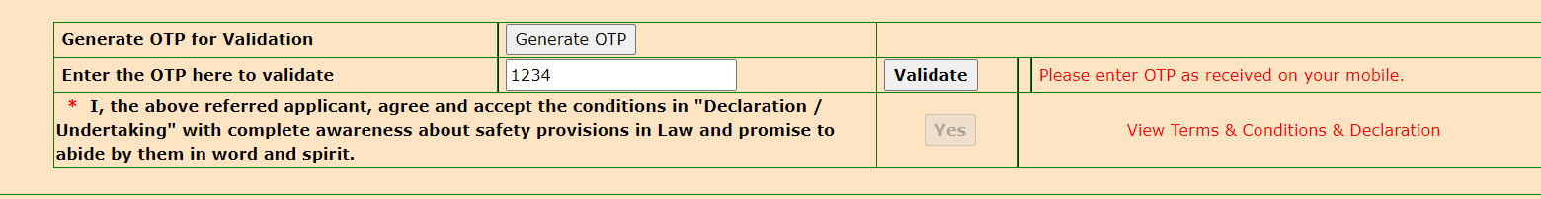

1. Unwanted message displaying on home page

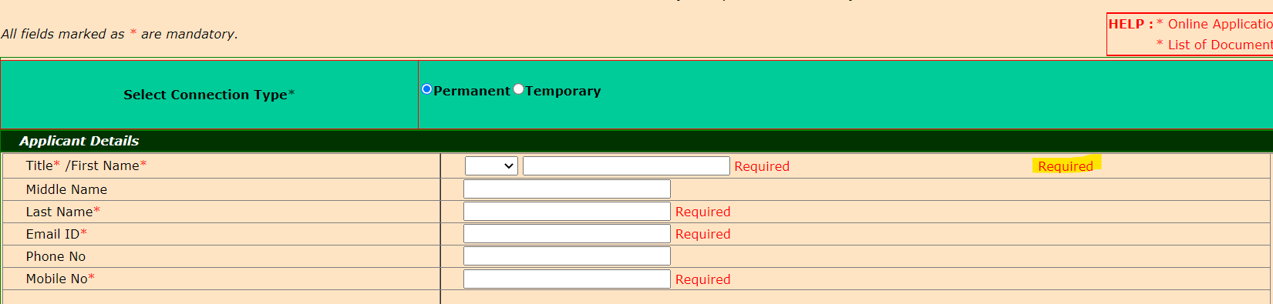

1. After selecting the values in dropdown user is navigating to top of the application. User should remain on current element

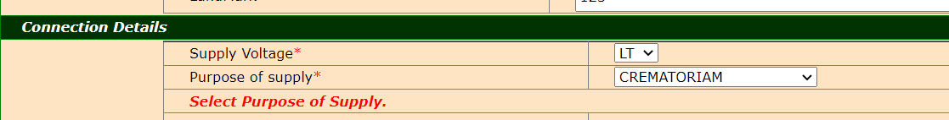

1. User should get appropriate error message when entered wrong OTP

